STORAGE ACCOUNT & AZURE STORAGE EXPLORER **DATA CONNECTION**

Theophila Murphy S

DE-Batch 6

**STORAGE ACCOUNT CREATION**

In Search Bar type – Storage accounts

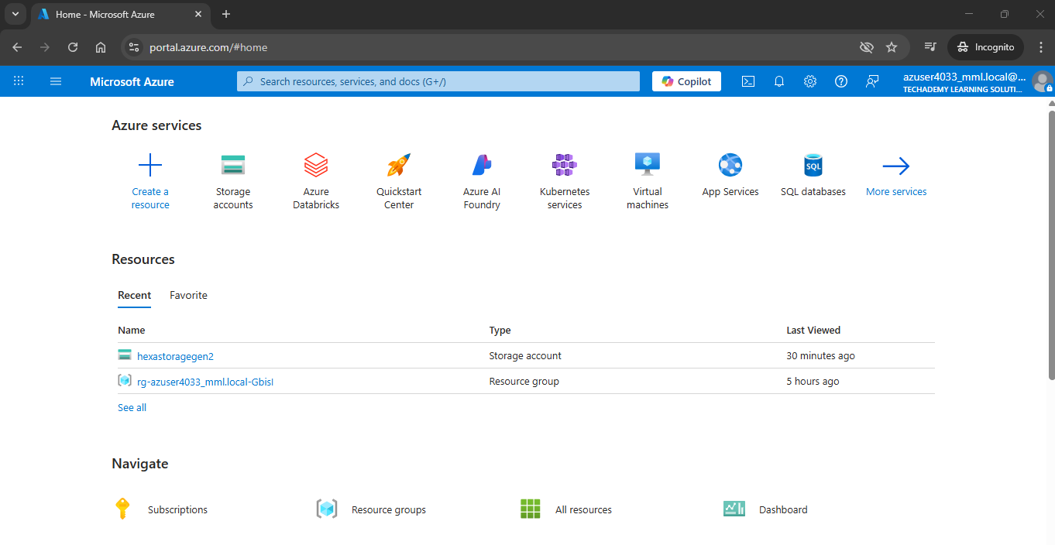

Click Create in the Storage accounts

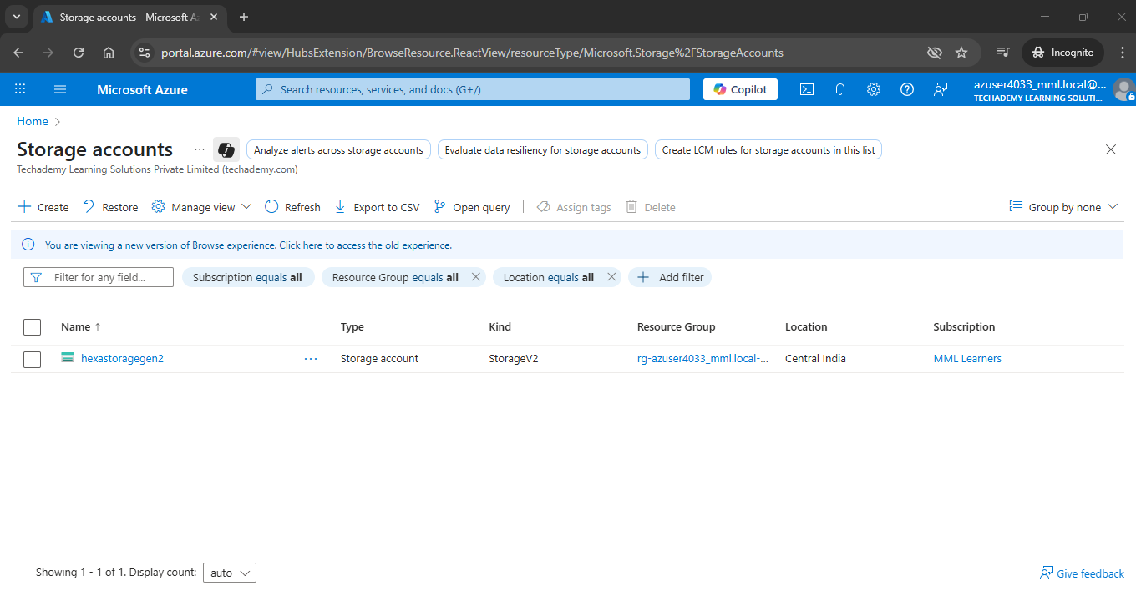

Type the Storage account name

Primary service – Azure Blob Storage or Azure Data Lake Storage Gen2

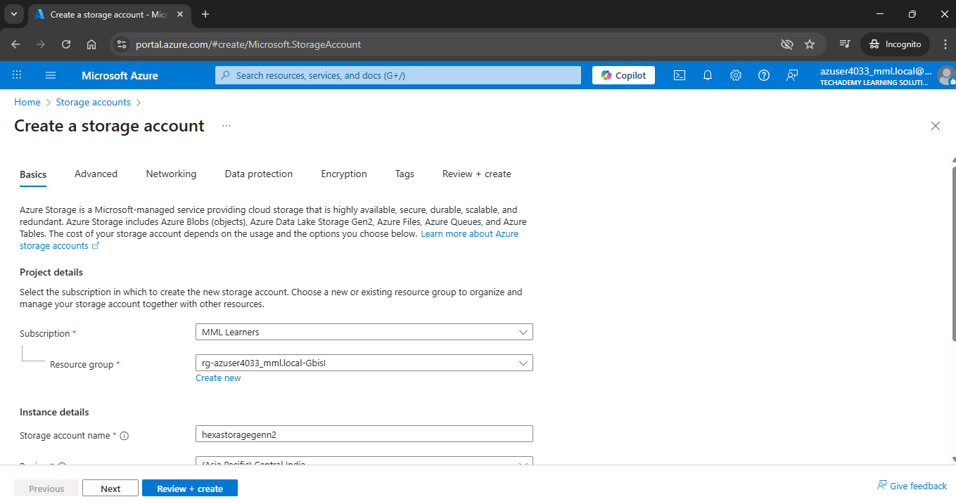

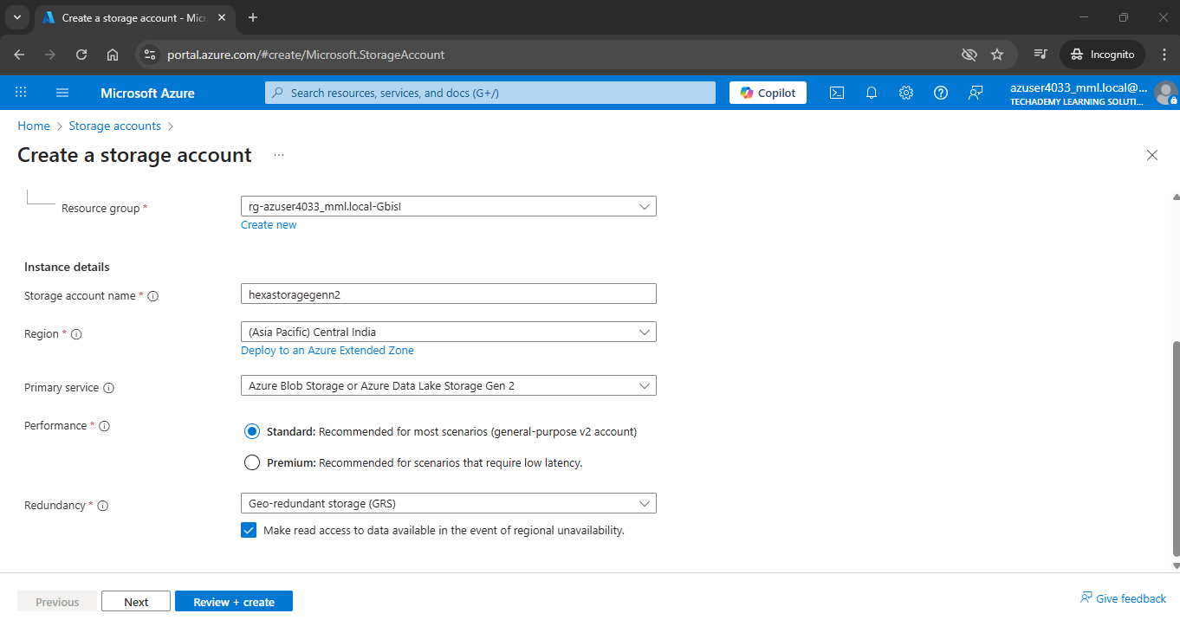

Click Advanced Tab

Select the following :

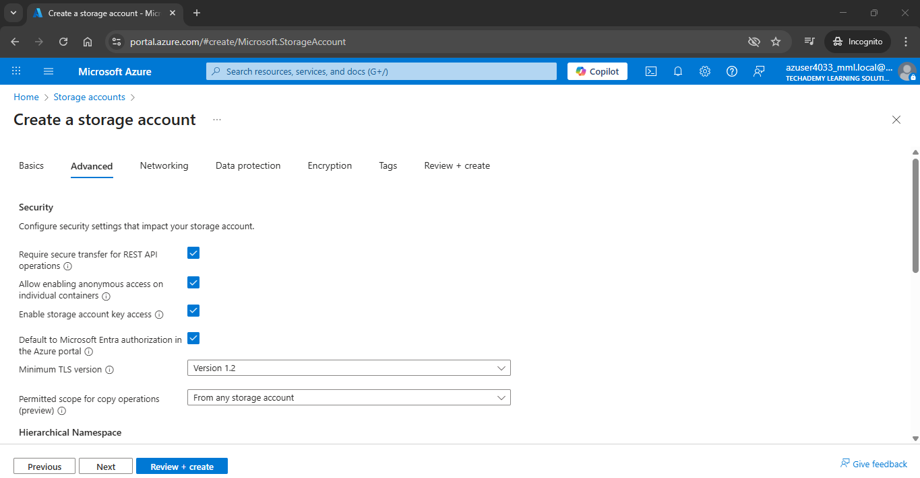

Select Hierarchical namespace

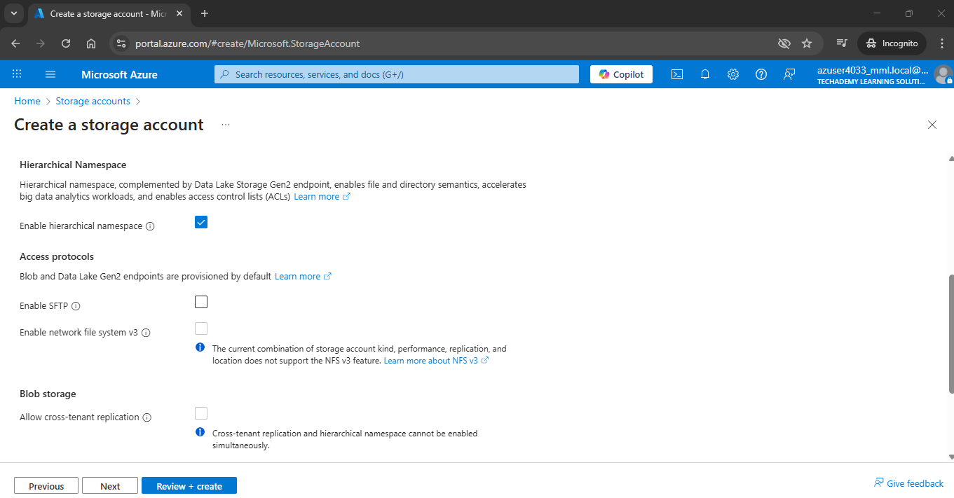

Click review and Create

Then Deployment Succeed

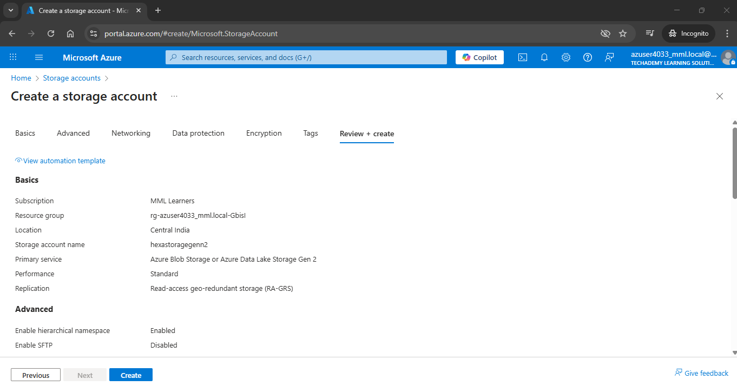

Now Container displayed in the Storage accounts



Click that Storage account- hexastoragegen2

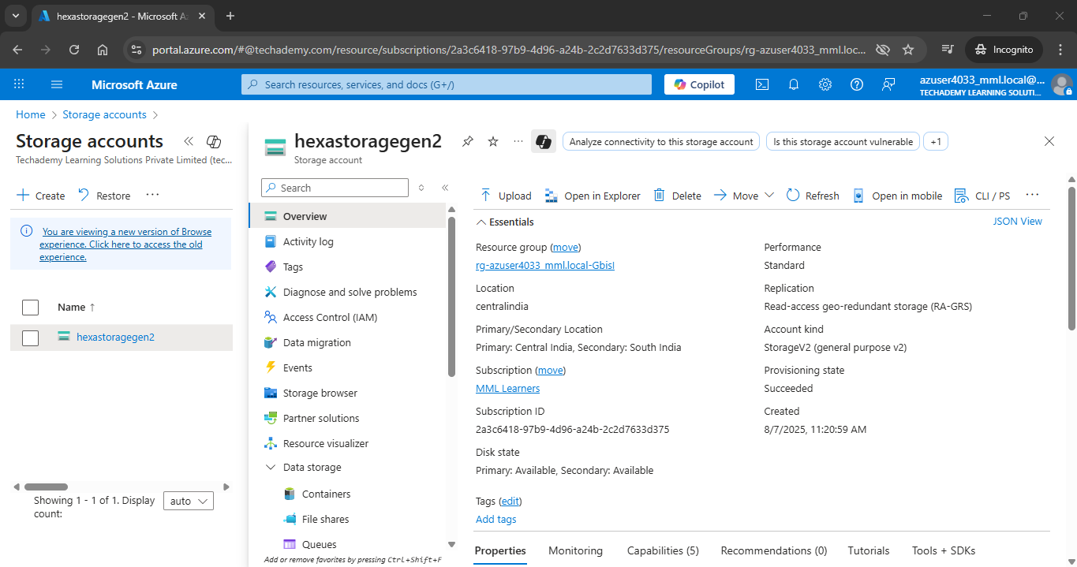

Now Add Container in the (hexastoragegen2)Storage accounts

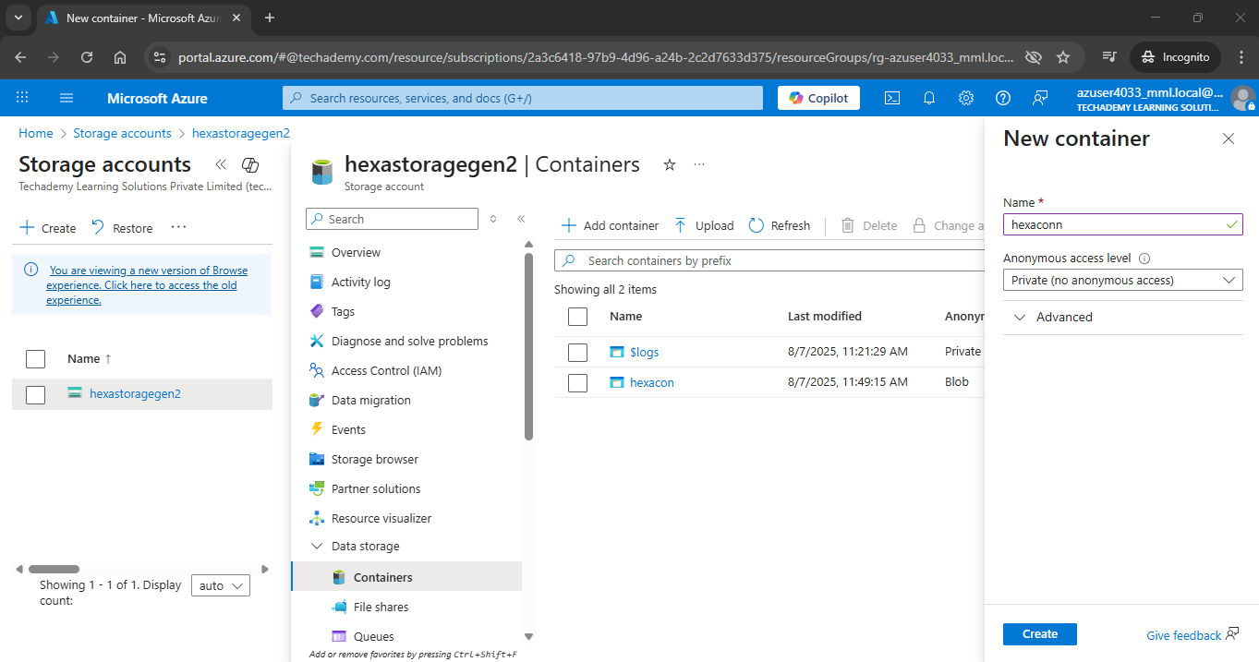

Click Container hexacon

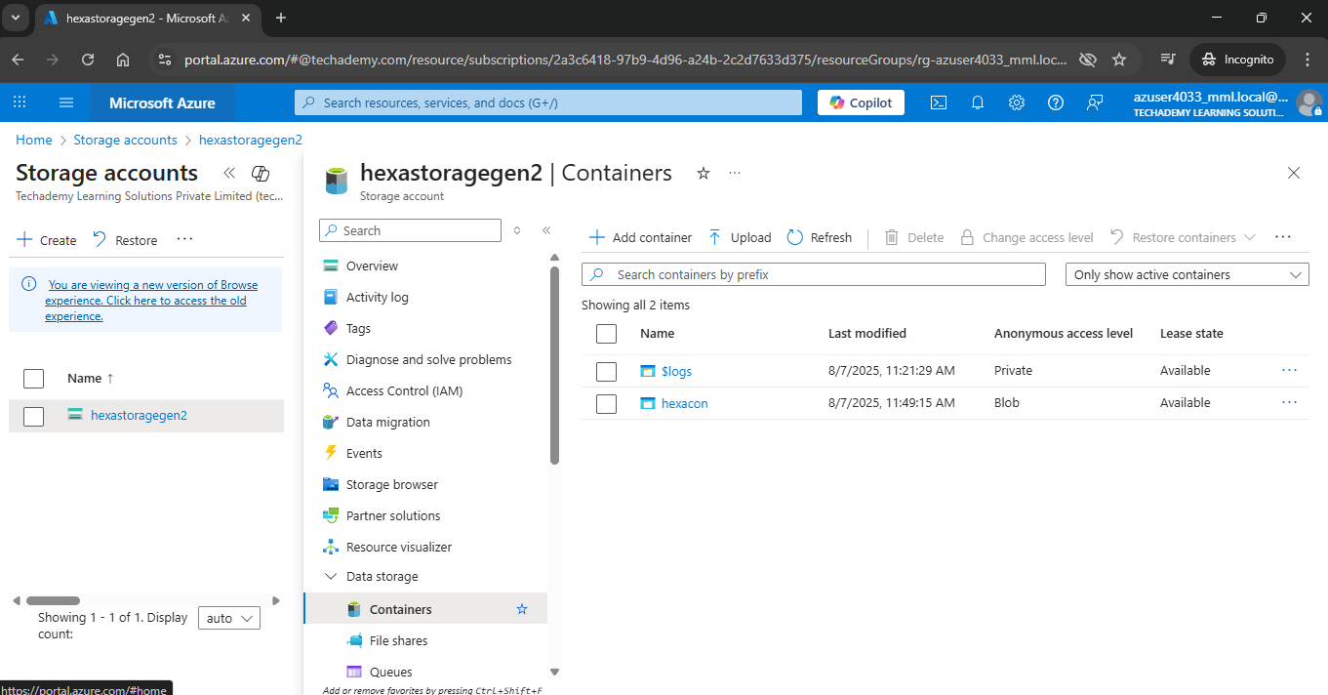

Click Upload

And upload the file

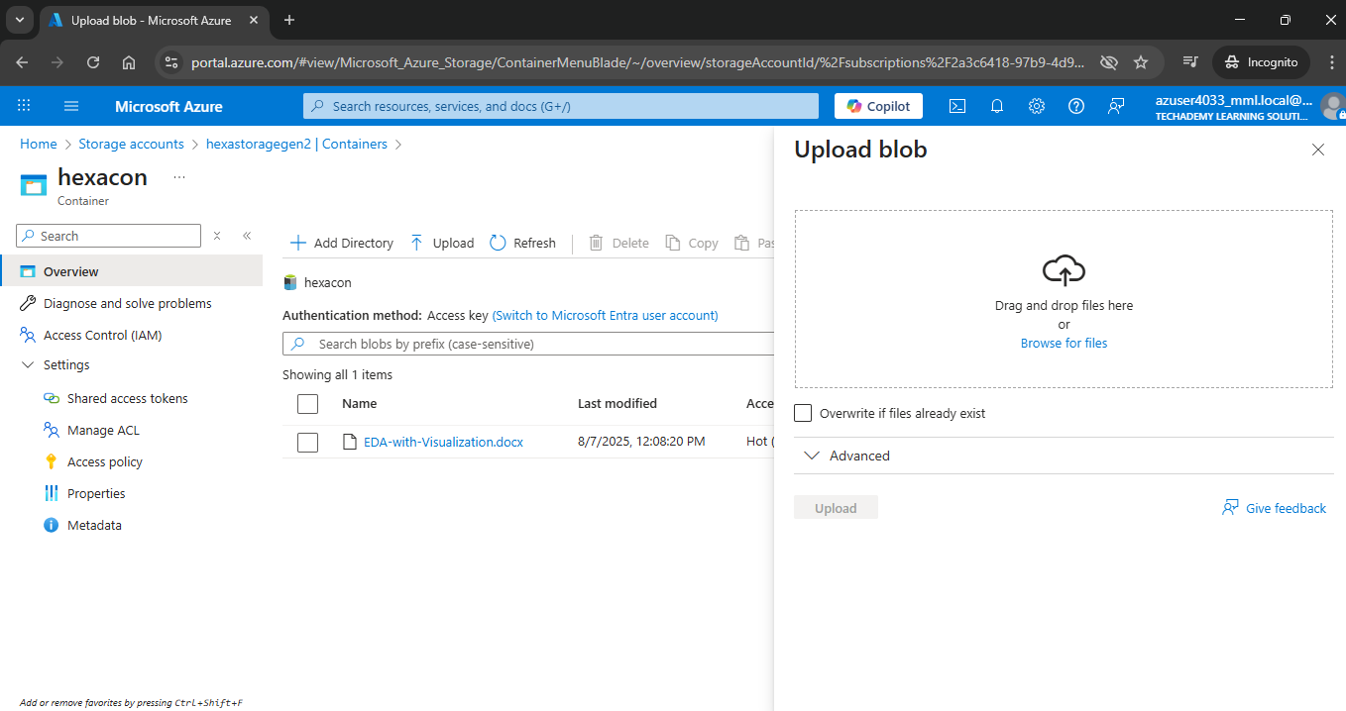

Now Click Shared access token

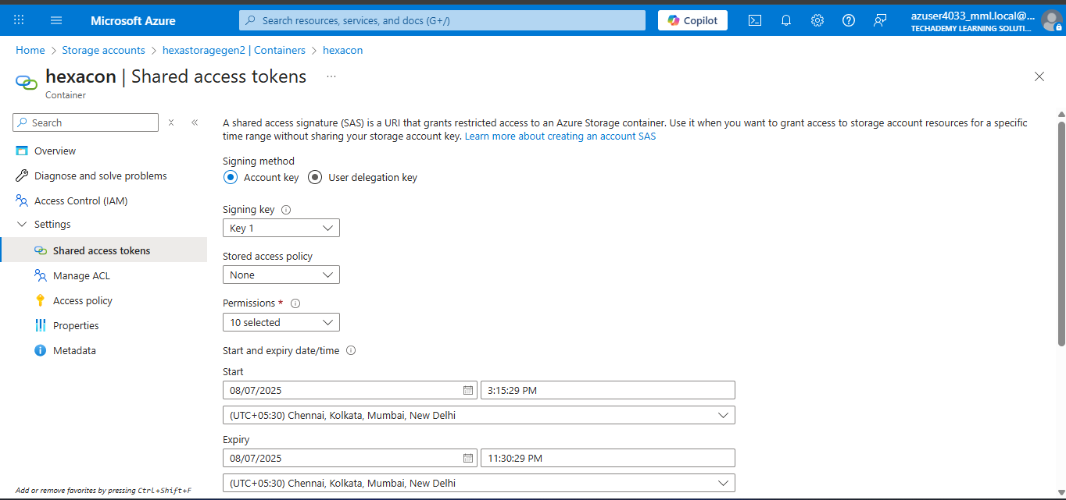

Copy the Blob SAS URL

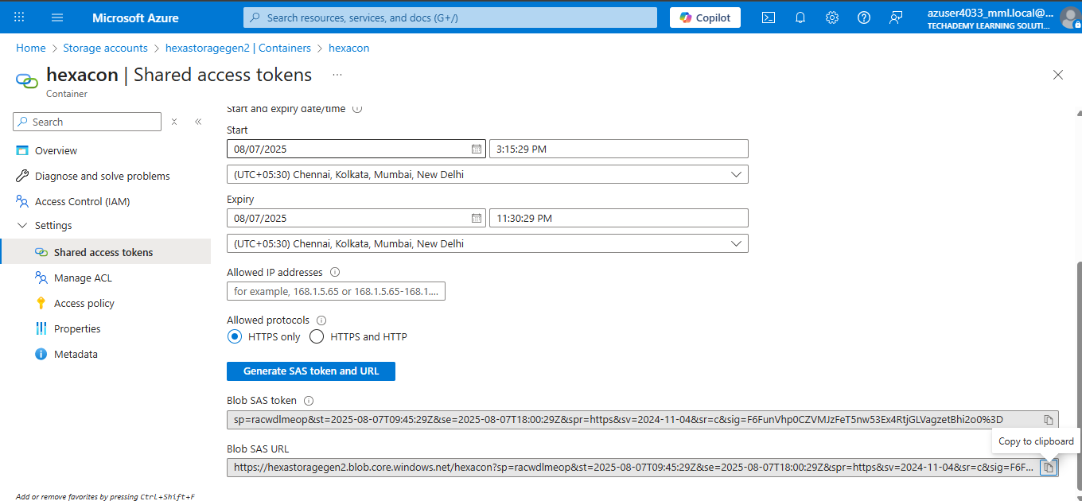

AZURE STORAGE EXPLORER **DATA CONNECTION**

Open Microsoft Azure Storage Explorer

Click Storage Accounts

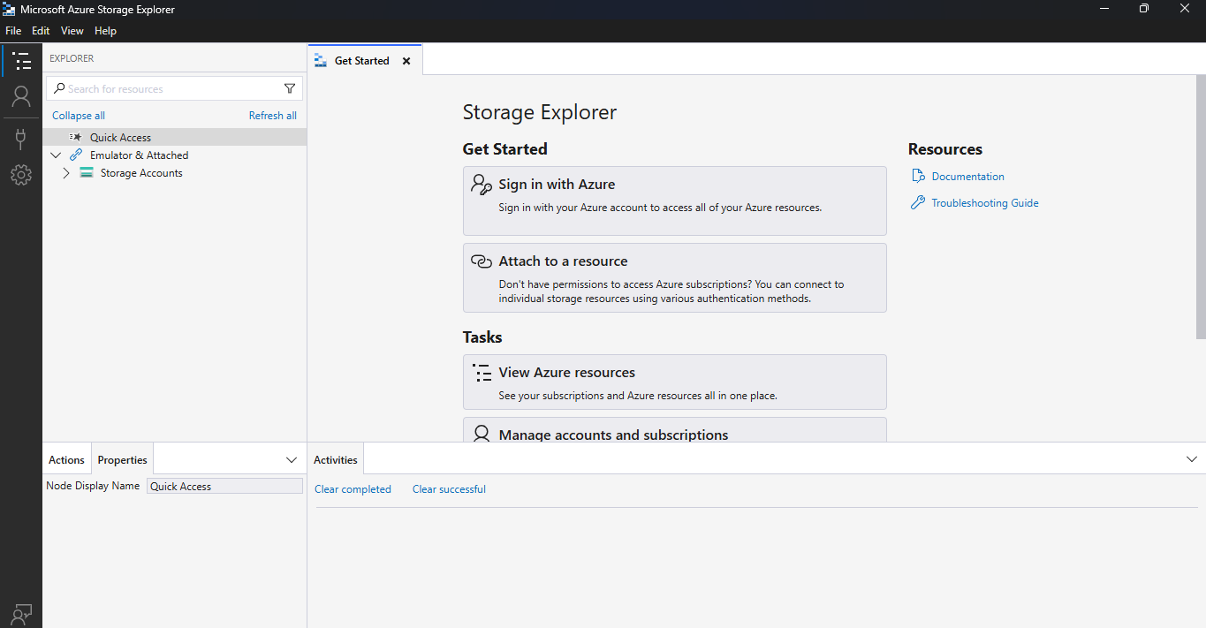

Click Attached Container

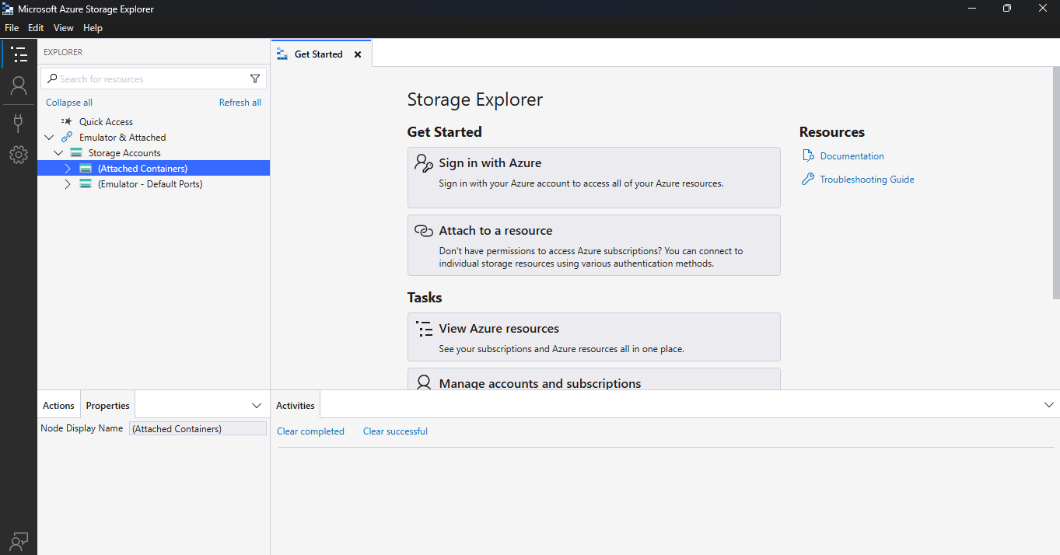

Click Blob Containers

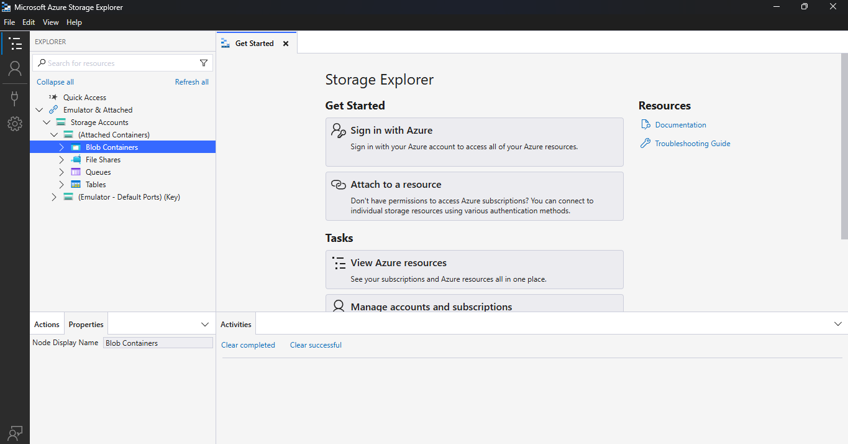

Click Connect to Azure resources

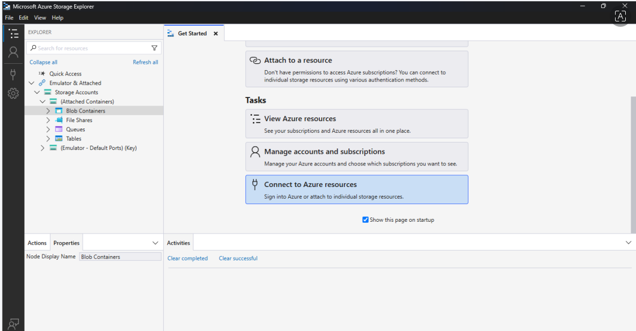

Click Blob Container or directory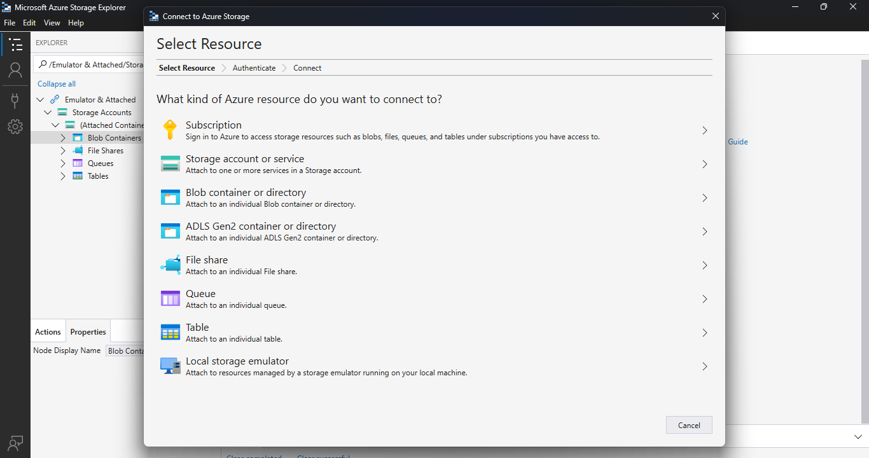

Click Shared access signature URL (SAS)

Click Next (at bottom)

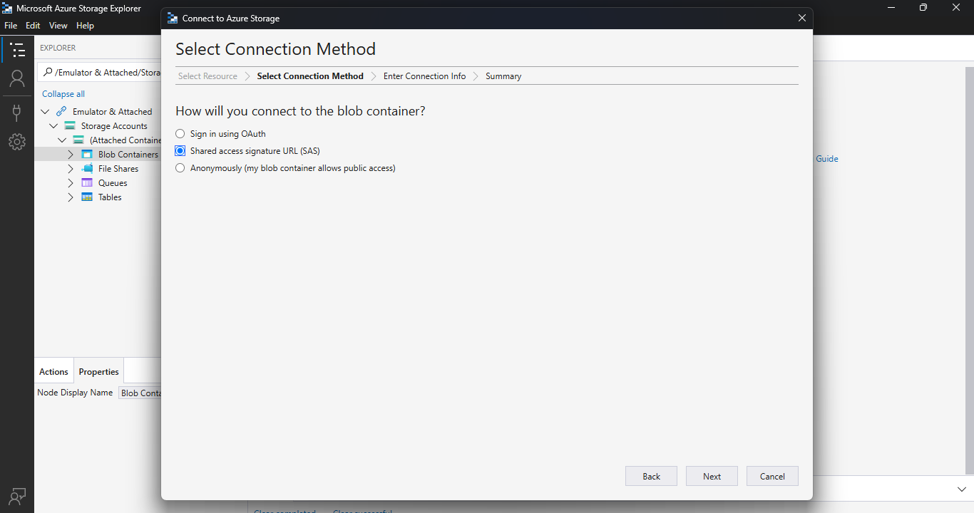

Copy paste the Blob SAS URL (copied in the container Shared access -Azure)

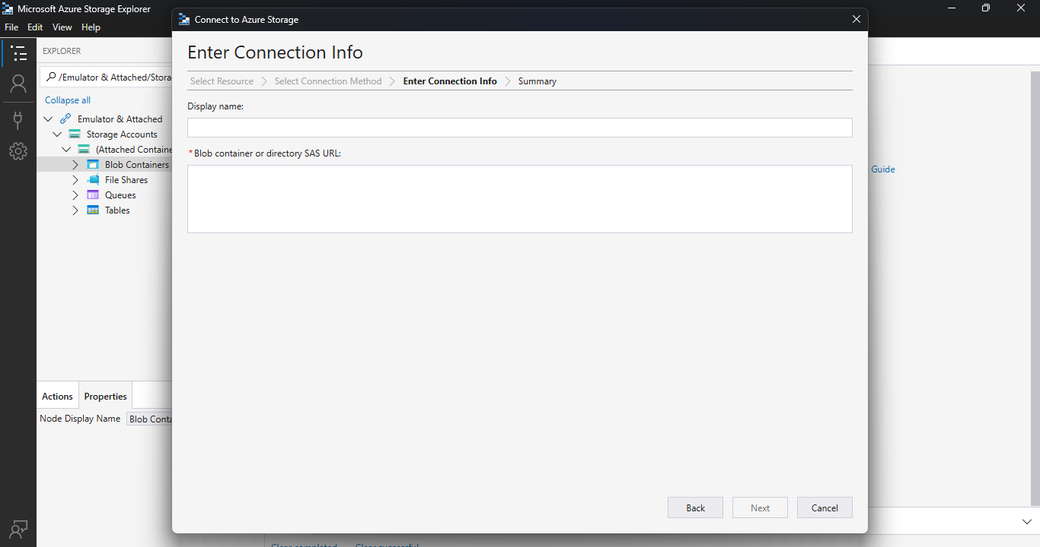

After pasting the URL – Display name(container name)displayed automatically

Click Next

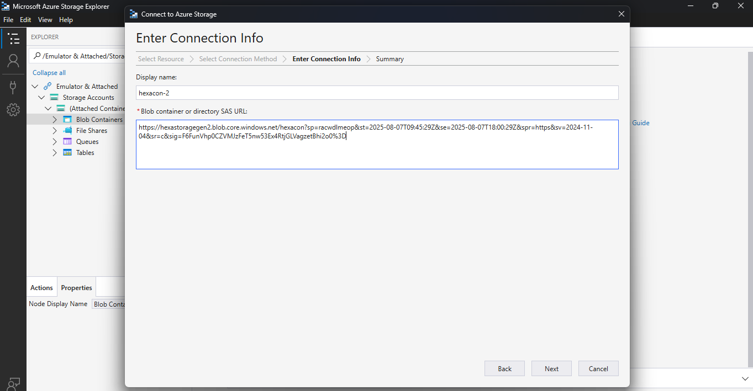

This will pop up

Click Connect

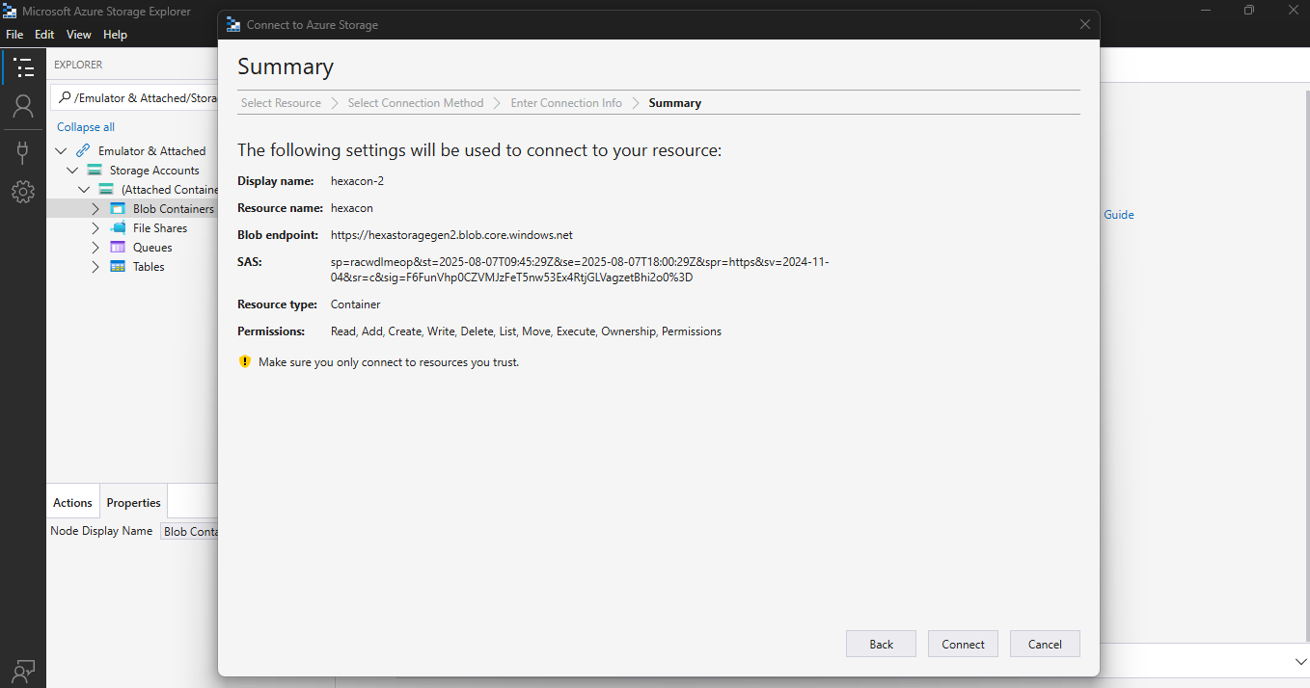

The Data Lake is connected successfully

And the file uploaded in storage account also displayed in the Microsoft Azure Storage Explorer

